|  |
| --- |
| **REZWANA BINTE REZA** |
| Address: 39/1/G, Baishtakey , Mirpur-13 ,  Dhaka-1216. Mobile : 01676234640  e-mail : rezwana.reza@yahoo.com |

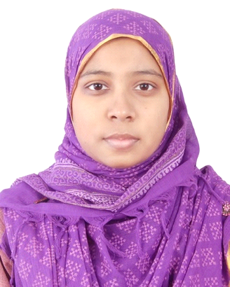

**Career Objective:**

To obtain a challenging position in a well reputed organization that will utilize my talent properly and provided me with the opportunity of enhancing my skill and professionalism eventually I would like to work as a successful person.

**Employment History:**

**Total Year of Experience:** 4 year

**System Engineer (May 05, 2014 - May 30,2018)**

**Telecommunication Department**

**iBMS Technology Bangladesh Ltd.**

**Educational Background:**

|  |  |  |  |  |  |
| --- | --- | --- | --- | --- | --- |
| **Exam Title** | **Concentration/Major** | **Institute** | **Result** | **Pas.Year** | **Duration** |
| Bsc. Eng | Electrical and Electronics Engineering | United International University | 3.54 out of 4 | 2013 | 4 years |
| H.S.C | Science | BCIC College | 5out of 5 | 2008 | 2 years |
| S.S.C | Science | Islamia Adarsha High School | 4.69 out of 5 | 2006 | 2 years |
| |  |  |  |  |  |  | | --- | --- | --- | --- | --- | --- | | **Training Title** | **Institute** | **Country** | **Location** | **Year** | **Duration** | | CCNA | United International University | Bangladesh | Dhaka | 2015 to 2016 | 8 months |   **Training Summary:** | | | | | |

**Thesis:**

* ECG feature extraction and detection of various heart conditions.

**Key Skills:**

* **IT Skills:** Ms Word, Ms Power point, Ms Excel, Ms Outlook.
* **Engineering software:** MATLAB, PSpice, Visual studio, Electrical Work Bench, Orcad, AutoCAD (2D), Packet Tracer.

**Personal Details:**

|  |  |  |
| --- | --- | --- |
| Father's Name | : | Md. Razaul Karim |
| Mother's Name | : | Arfatun Nahar |
| Date of Birth | : | September 13, 1991 |
| Gender | : | Female |
| Marital Status | : | Married |
| Nationality | : | Bangladeshi |
| National Id No. | : | 19912693004000647 |
| Religion | : | Islam |
| Permanent Address | : | 39/1-G, Baishtakey, Hazi Ali Hossain Road, Mirpur-13, Dhaka-1216. |
| Current Location | : | 39/1-G, Baishtakey, Hazi Ali Hossain Road, Mirpur-13, Dhaka-1216. |

**Reference:**

**Dr. Raqibul Mostafa Md. Hasanul Bari**

Associate professorDGM

Head of the EEE Department Crystal Future Venture Limited (CFVL)

United International University Phone: 01613387101

Phone: 01713123572 E-mail: bari@cfvl.com.bd

E-mail: rmostafa@eee.uiu.ac.bd

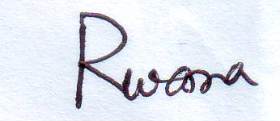

**Rezwana Binte Reza**